TITLE OF THE ARTICLE

^{1*}Name SURNAME, ²Name SURNAME, and ³Name SURNAME

^{1,2} Institution, address  E-mails:¹ nnn@xxxx.xx; ²xxxx@xxx.xx  ORCID: ¹https://orcid.org/0009-0000-3492-4074,  Corresponding Author’s email address*: robin@vste.cz  Received:…..; accepted….; published…..  Keywords: keyword, keyword, keyword, 3-5 keywords  JEL codes: JEL code 1, | Abstract: Provide a concise summary of the study, including the research objective, methodology, key findings, and main conclusions. The abstract should be written as a single paragraph and should be between 150 to 200 words. Avoid citations, abbreviations where possible, and references to tables or figures.
How to Cite This Article: Surname, F. M., Surname, F. M., & Surname, F. M. (2026). Title of the article. Littera Scripta, 19(1), xx–xx. https://doi.org/10.36708/xxxxx

- Introduction

Here is an introduction to your topic. This section should introduce the research topic, establish its relevance, identify the research gap, and state the study's objectives. Citations should follow the author–date referencing style.

Examples of in-text citations: One author: (Vochozka, 2024); two authors: (Kasych & Vochozka, 2018); three authors: (Kunju Mol Raj, Vochozka, & Apanovych, 2025); four or more authors: (Vochozka et al., 2026).

- Literature Review and Theoretical Background (Optional)

This section should summarize the relevant literature, discuss the study's theoretical foundations, identify research gaps, and establish the study's academic context. Authors should critically evaluate existing knowledge and demonstrate how the current study contributes to the literature.

  - Theoretical Background (Optional)
Present the theories, concepts, models, or frameworks that underpin the study and explain their relevance to the research objectives.

  - Literature Review (Optional)

Review and critically discuss previous studies related to the research topic, highlighting key findings, limitations, and areas requiring further investigation.

  - Hypothesis Development (Optional)

Where appropriate, formulate research hypotheses or propositions based on theoretical arguments and prior empirical evidence. This subsection is not required for exploratory, descriptive, qualitative, legal, review, bibliometric, or methodological studies.

- Materials and Methods

This section should provide sufficient detail to enable the study to be replicated. Authors should clearly describe the research design, data sources, variables, sampling procedures, analytical methods, software used, and any assumptions or limitations relevant to the methodology.

  - Data

Describe the data used in the study, including data sources, collection procedures, sample characteristics, study period, and variable definitions. Where applicable, provide descriptive statistics and summary information.

Tables should be numbered consecutively and cited in the text. Table captions should appear above the table and be formatted in Times New Roman, 10 pt.

An example of Table 1 is written below:

Table 1. Descriptive Statistics of Sentiment, Polarity, Subjectivity, and VADER Score. The table and figure caption should be Times New Roman with 10 pt.
Statistic | Sentiment | Polarity | Subjectivity | VADER Score
count | 11486 | 11486 | 11486 | 11486
mean | 0.105 | 0.105 | 0.398 | 0.685
min | -0.700 | -0.700 | 0.000 | -0.999
25 % | 0.063 | 0.063 | 0.357 | 0.788
50 % | 0.103 | 0.103 | 0.412 | 0.987
75 % | 0.144 | 0.144 | 0.458 | 0.997
max | 1.000 | 1.000 | 1.000 | 1.000
std | 0.085 | 0.085 | 0.112 | 0.589
Note: Briefly explain the contents of the table, abbreviations, statistical measures, or other relevant information. Notes should appear below the table.

  - Methodology

Clearly explain the analytical methods, models, procedures, algorithms, statistical tests, or theoretical approaches used in the study. All equations should be editable and numbered consecutively.

For example, the compound sentiment score (CS) is calculated using the following formula:

$$CS=\frac{\sum{(v×w)}}{\sqrt{\sum{{(v×w)}^{2}}}}$$ | (1)

Where the v (valence) represents the sentiment intensity of each word in the text (from the VADER lexicon), and the w (weight) represents the word's importance, adjusted by punctuation, capitalization, negation, and other heuristics.

All variables, parameters, and symbols should be clearly defined immediately after the equation. Authors should provide sufficient methodological detail to ensure transparency and reproducibility of the research.

- Results

This section should present the findings of the study in a clear and logical manner. Results should be reported objectively and supported by appropriate tables, figures, statistical outputs, or other evidence. Authors should avoid extensive interpretation in this section and focus primarily on presenting the findings.

Tables and figures should be numbered consecutively and cited in the text. Authors should ensure that all results are clearly explained and directly related to the research objectives, questions, or hypotheses.

Figures should be numbered consecutively and cited in the text. Figure captions should appear below the figure and be formatted in Times New Roman, 10 pt. For example, Figure 1 shows the sentiment distribution.

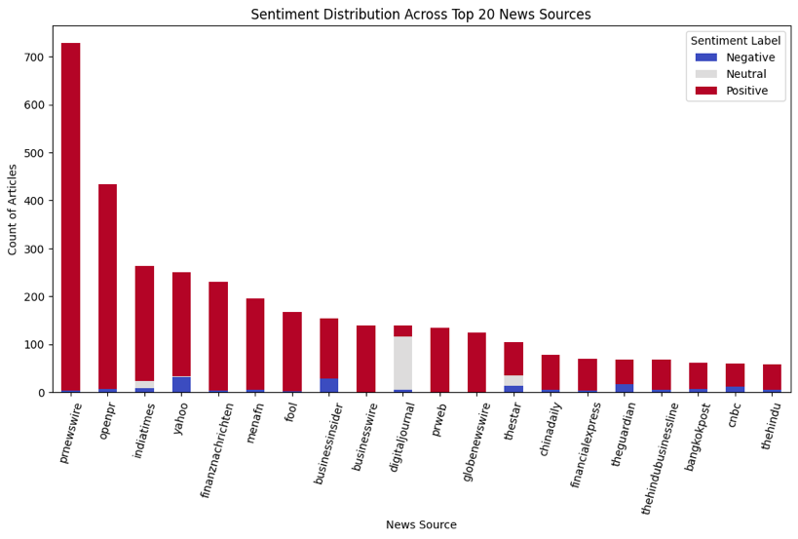
Figure 1. Sentiment Distribution Across Top 20 News Sources.
Note: The chart displays the distribution of sentiment-labeled news articles across the top 20 news sources, showing strong supremacy of positive sentiment, particularly in press release platforms like PRNewswire and OpenPR, while a few sources display a more neutral or negative stance on AI’s role in poverty (Kunju Mol Raj, Vochozka, & Sujatha, 2025).

- Discussion

This section should interpret and critically evaluate the findings presented in the Results section. Authors should explain the significance of the results, compare them with previous studies, discuss theoretical and practical implications, and address any unexpected findings.

The discussion should demonstrate how the study contributes to existing knowledge and should clearly relate the findings to the research objectives, questions, hypotheses, or theoretical framework. Authors are encouraged to discuss limitations and potential directions for future research where appropriate.

- Conclusion

The conclusion should summarize the study’s main findings and highlight their theoretical, practical, and policy implications, where relevant. This section should clearly state the research contribution and explain how the study advances understanding of the topic.

Authors should avoid introducing new results or citations in the conclusion. Where appropriate, limitations of the study and recommendations for future research may be briefly presented.

  - Limitations and Future Research (Optional)

Authors may discuss the limitations of the study and propose directions for future research. This subsection is particularly encouraged for empirical studies and studies involving methodological or data-related constraints.

Reference:

Kasych, A., & Vochozka, М. (2018). Methodical support of the enterprise sustainable development management. Marketing and Management of Innovations, 371–381. https://doi.org/10.21272/mmi.2018.1-29
Kunju Mol Raj, R., Vochozka, M., & Apanovych, Y. (2025). Watts and Wealth: Forecasting the Economic Pulse of Europe Through Electricity Consumption. Computational Economics. https://doi.org/10.1007/s10614-025-11070-4
Kunju Mol Raj, R., Vochozka, M., & Sujatha, S. (2025). Sentiment analysis of news: Unveiling AI’s role in sustainability and no poverty (SDG1). Discover Sustainability, 6(1), 592. https://doi.org/10.1007/s43621-025-01456-7
Vochozka, M. (2024). Blank Drafts to Secure Obligations Without Financial Risk. AD ALTA-JOURNAL OF INTERDISCIPLINARY RESEARCH, 14(1), 271–276.
Vochozka, M., Raj, R. K. M., Šanderová, V., & Turinska, L. (2026). Forecasting Slovak GDP based on metal commodity prices as a tool for policymakers. Retos, 16(31), 135–160. https://doi.org/10.17163/ret.n31.2026.08

We recommend using ZOTERO for references. Then American Psychological Association, 7th edition style is preferred: https://www.zotero.org/download/

Declarations

Funding: Please provide details of all sources of financial support for the research reported in this manuscript, including grant numbers where applicable. If no funding was received, please state: "The authors received no specific funding for this work."

Data Availability Statement: Authors should provide information on where the data supporting the reported results can be accessed, including repository names, persistent identifiers (DOI), or conditions for access. If no data are available, authors should state the reason.

Author Contributions: Please specify the individual contributions of each author to the manuscript. Use author initials where possible. If the manuscript has a single author, please state: "The author confirms sole responsibility for all aspects of this work."

Artificial Intelligence (AI) Usage Statement: Authors must disclose any use of artificial intelligence (AI) tools, including generative AI systems, in the preparation of the manuscript. AI tools may be used to assist with language editing, grammar checking, coding, data processing, or other technical tasks; however, authors remain fully responsible for the accuracy, originality, integrity, and content of the manuscript. AI tools cannot be listed as authors.

Conflict of Interest: The authors must disclose any financial, professional, personal, or institutional relationships that could be perceived as influencing the research reported in this manuscript. If no conflicts exist, please state: "The authors declare no conflict of interest."

Ethical Approval: For studies involving human participants, animals, or sensitive data, authors must provide information regarding ethical approval obtained from the appropriate ethics committee or institutional review board. If ethical approval was not required, please mention “Not Applicable”

Informed Consent: For research involving human participants, authors must confirm that informed consent was obtained from all participants or their legal representatives where applicable. If informed consent was not required, please state “Not Applicable”.

Contact address of the author(s):

doc. Name Surname, Ph.D., Department, Faculty, Institution, Address, Country/State, e-mail: email@email.com

Prof. Name Surname, Ph.D., Department, Faculty, Institution, Address, Country/State, e-mail: email@email.com

General Formatting Requirements

- Manuscripts must be written in English.
- Use Times New Roman, 12 pt, single spacing. (Except the abstract, it should be 10 pt.)
- Margins should be 2.5 cm on all sides.
- All pages should be numbered consecutively.
- Tables and figures must be editable (Use Times New Roman, 10 pt, single spacing).
- References must follow APA (7th edition).
- The total length of the manuscript should be 4000 to 6000 words, including tables, figures, references, declarations, and appendices.

